Algebra 1- Week 10 Homework

Monday- Test review! Study for test!!! Topics on test:
- Analyze Linear Functions- Does a certain point fall on the line of the linear equation?
- Graphing Linear Functions Using Given Information- Writing a linear equation that passes through two points or passes through one point with a given slope.
- Graphing Linear Functions in Standard Form- Calculate the x- and y-intercepts of a standard form linear equation or solving the equation of the line for its y-coordinate (put it in slope intercept form) in order to graph the function. As well as creating an equation for a line in standard form by analyzing a real world scenario.
- Graphing Parallel and Perpendicular Lines- Graph and write equations of lines that are parallel and perpendicular by understanding the relationship between the slopes of a pair of lines.

Tuesday - Test day! No homework!

Wednesday/ Thursday-
y = 2x + 4
3x + y = 9

y = x - 5
y = -3x +3

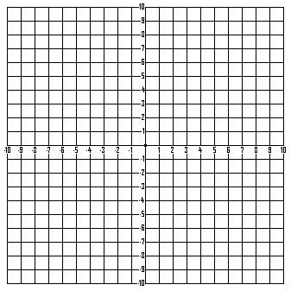

(Left)
Solution:

( , )

(Right)
Solution:

( , )

Friday- No school!

