Algebra 1- Week 13 Homework

Monday-
- Graphing Linear Systems of Equations: Graph both equations in y = mx + b format (m=slope, rise/run; b=y-intercept, start value). One solution- where they intersect; no solutions- parallel lines, will never intersect; infinite solutions- same exact line.
- Solving Linear Systems of Equations with Substitution: Take one equation in the system and replace a variable in the other equation with itself. (Ex: y = 2x+1 and 2x + 4y = 14 ---> 2x + 4(2x + 1) = 14)
- Solving Linear Systems of Equations with Elimination: Eliminate a variable (x or y). In order to do so, the coefficient MUST form a zero pair when the equations are added or subtracted. You may need to multiply the entire equation by a constant in order to make a zero pair. (Ex: x + y = 14 and 2x - y = 2, add them together (x + y = 14) + (2x - y = 1) ---> (x + 2x) + (y - y) = (14 + 1) ---> 3x = 15 ---> x = 5)
- Systems of Equations: Real World Applications: Write two equations from a scenario either in slope -intercept form (y = mx + b, where m = slope / constant rate of change / "per", and b = start value) or in standard form (Ax + By = C, where C = total, and A and B = the values being added). Then using one of our methods to solve a system of equations (graphing, substitution, or elimination).

Tuesday/Wedensday- Test! No Homework!

Thursday-
Solve the two problems below. Then, describe the similarities and differences in their solution using at least 4 sentences.
3x + 4 = 2x + 6 | 3x + 4 < 2x + 6

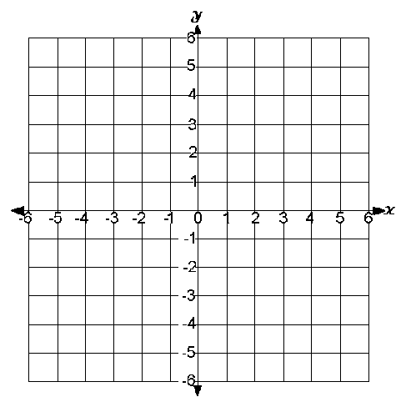
Friday-
- Graph the inequality y ≤ ¼x+ 2 on the coordinate plane to the right.

- Name two points that lie in the solution set.

- Is the point (0,2) in the solution set of this inequality? Justify your response in complete sentences.

