Algebra 1- Week 14 Homework

**Monday-**

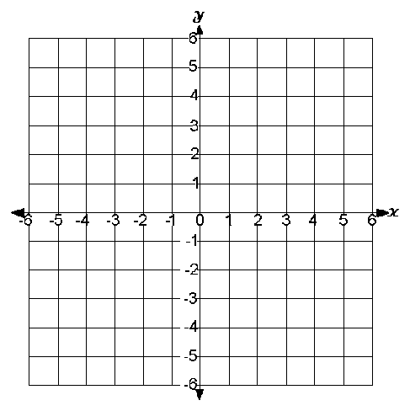Graph the following system of inequalities: **y > 5x – 1 and -2y ≤ 4x + 6.** Then, identify two points that are solutions, and two points that aren’t solutions.

**Two Solutions: ______________, ______________**

**Two Non-Solutions: ______________, _______________**

**Tuesday-**

Graph the system of inequalities below. Then, identify the shape of the shaded solution region.

**y > x + 1 y ≥ x – 5 y < 3 y ≥ -4**

**Wednesday**-

Mary babysits for $4 per hour. She also works as a tutor for $6 per hour. She is only allowed to work 12 hours per week. She wants to make at least $60. Write and graph a system of inequalities to represent this situation. Then, use your graph to name the best combination of hours that Mary should work.

**Thursday-**

Test review! Study for test!!! Topics on test:

1. **Solving Linear Inequalities**
2. **Graphing Linear Inequalities**
3. **Graphing Systems of Linear Inequalities**
4. **Application of Linear Systems of Inequalities**

**Friday-** Test! No Homework!