Algebra 1- Week 1 Homework

Monday/Tuesday-
- Create a relation that is a function using a table, mapping diagram, or ordered pairs. | - Create a relation that is not a function using a table, mapping diagram, or ordered pairs.
- Create a relation that is a function using a graph. | - Create a relation that is not a function using a graph.

Wednesday-
Ms. Davison has $43 dollars on her SmartTrip card. It will cost her $5 dollars each time she rides the train.
- Create a table depicting this situation: | - What is the domain?
- What is the range? | - Is this function continuous or discrete? Justify your response.

Thursday/Friday-
Given the graph of f(x) to the right, find:  - f (3)  2) the value of f(x), when x = 4  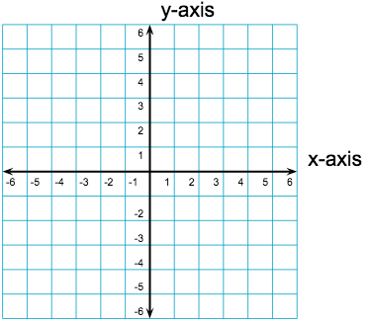 | Given the equations of the functions below,  j(x) = 2x + 1 p(c) = -3c  Find:  - j(10) =  - p(6) =

