Algebra 1- Week 2 Homework

Monday-
Ms. Davison has 23 notifications on her Facebook page. She receives 14 new notifications each day. Write an equation that shows the relationship between the total number of notifications f(x), for x days.

- Equation:

- What does f(x) represent in the context of the problem?

- What does x represent in the context of the problem?

- How many notifications would Ms. Davis have after 8 days?

  - f ( ) =

Tuesday-
1. Write a scenario below that shows a constant rate of change. Then, write an equation that shows the relationship between your input, x, and the output, f(x).

Equation

2. Create a table:  x  ________________  f(x)  ________________ | 3. Calculate f(100) using your equation:

Wednesday-
CD Sales
(in millions)
x | f(x)
2005 | 600
2008 | 450
2011 | 300
2014 | 150

1) Calculate the rate of change for the table on the left using the slope formula.

2) Is the rate of change positive or negative? Justify your response using the context of the table.

3) Write an equation below that shows the relationship between the number of CD’s purchased since 2005 f(x), to time x.

Thursday/Friday-
y = 1/5x - 2

m:_______ b: ( 0, )
y = -3x + 6

m:_______ b: ( 0, )

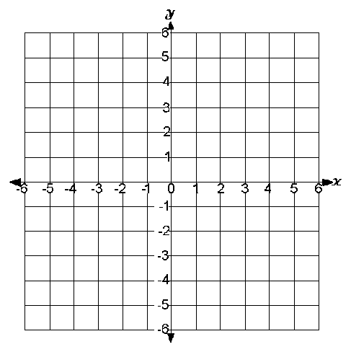

y = 2x + 5

m:_______ b: ( 0, )
y = 5

m:_______ b: ( 0, )

