Algebra 1- Week 3 Homework

Monday-
f(x) = |x+ 4| - 1

a:_______ vertex: ( 0, )

f(x) = |x| - 1

a:_______ vertex: ( 0, )

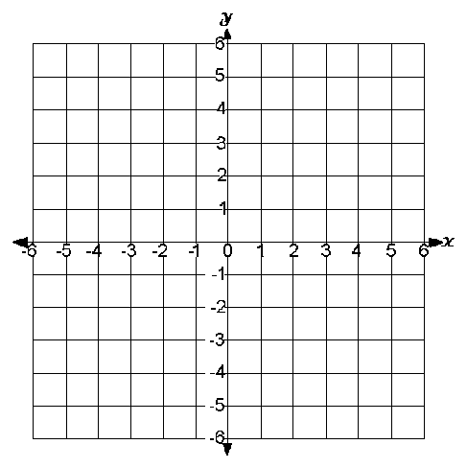

Tuesday-
f(x) = 1/3|x - 2| - 4

a:_______ vertex: ( 0, )

f(x) = -2|x| + 5

a:_______ vertex: ( 0, )

Wednesday, Thursday- Finish up ‘What’s Your Function’ Performance Task.

We have spent the beginning of the school year learning how to read, create and apply different types of functions to better understand our world. This project will be part of the demonstration of your understanding of the unit concepts.

Each project must contain the following elements:
- Typed up written response that includes the following:
-Clear Title for the project (1 point)

-Identification and explanation of the variables (independent and dependent) in your function (4 point)

-Explanation of the domain and range for your function (4 points)

-Description of the relationship in the function (discrete or continuous) and why (4 points)

-Identify what type of function best describes your function (linear, exponential, quadratic) and why (2 points)

- Reflection Critique of the process (3 points)
-What the group did well on the project (relative strengths)

- What the group can work on/improve upon for next time

- What the group learned about functions and themselves

- Display of your function using function notation (5 points)

- Graph of your function (10 points) – include title, label axes, appropriate scale and units

- Table of values for your function (7 points) – include at least 5 inputs/outputs and correct labeling.

What’s Your Function Project Rubric

 | 4 | 3 | 2 | 1
1. Elaboration and Clarification | Presentations demonstrates excellent elaboration and use of relevant detail to clarify main points in presentation | Most parts of presentation elaborate and use evidence to clarify the main points of the presentation | Few parts of the project are elaborated on and only main ideas are presented without proper clarification and/or follow-up | Many parts of the presentation fail to elaborate on or identify the main idea being made in the project.
2. Justification and use of evidence | Detailed evidence is given to support answer and all of the information and analysis is correct, insightful, AND relevant to the project | Gives evidence to support the presentation, but only minimally analyzes the evidence AND/OR is off topic at times | Gives evidence to support the presentation, but some of the information is incorrect or the analysis is weak | Gives inappropriate evidence to support the presentation OR fails to support the presentation
3. Group Work | The group demonstrated excellent collaboration and interpersonal skills in completing the project. | The group demonstrated collaboration and interpersonal skills in completing the project. | The group demonstrated limited collaboration and interpersonal skills in completing the project. | The group demonstrated minimal collaboration and interpersonal skills which interfered with the completion of the project.

4. Content (40 points – see Performance Task list for details): ________
Total Points (out of 52): Grade:
Strengths: Areas for revision:

