Algebra 2 Honors- Week 11 Homework

Monday- Modeling the Speed of a Tsunami Activity- Finish whatever you did not finish during class.
Things you may need to know:
Alaska: 57.7931 degrees N, 152.3942 degrees W
Oregon: 44.6044 degrees N, 124.0547 degrees W
Hawaii: 19.7056 degrees N, 155.0858 degrees W

1 degree = 110 kilometers (N to S)
1 degree = 70 kilometers (E to W)
1 kilometer = 1000 meters
$a^{2}+b^{2}= c^{2}$ a c

b

Tuesday-
Transformation of Quadratic Functions Assignment
1. Write a function to represent the total area.

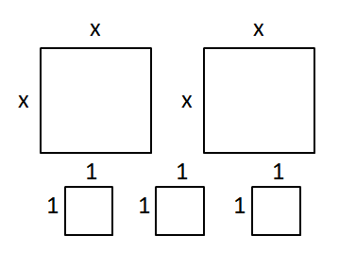

Draw a picture of the squares and sketch a graph for each function.
2. $f\left(x\right)=\frac{1}{2}x^{2}$ 3. $f\left(x\right)=x^{2}-5$ 4. $f\left(x\right)=2x^{2}$+3
Write a function to represent each graph.
5. 6. 7.

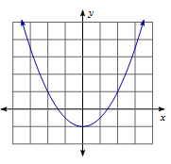
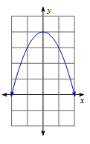
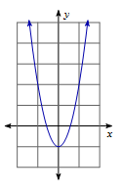

8. Write the equation of a quadratic function that translates up 12 and stretches by 5.
9. Write the equation of a quadratic function that translates down 3 and shrinks by 5.

10. Describe the similarities and differences between:
$f\left(x\right)=x^{2}-1$ $f\left(x\right)=x^{4}-1$
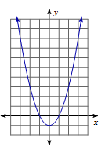
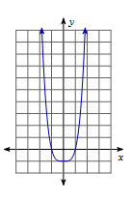

Wednesday-
Transformation of Quadratic Functions Day 2 Assignment
Draw a picture of the squares and sketch a graph for each function.
1. $f\left(x\right)=3{\left(x+4\right)}^{2}$ 2. $f\left(x\right)=-4{(x-1)}^{2}+6$ 3. $f\left(x\right)=\frac{1}{3}{(x-2)}^{2}+1$ 4. $f\left(x\right)=\frac{5}{2}{(x+2)}^{2}-1$
Write a function to represent each graph.

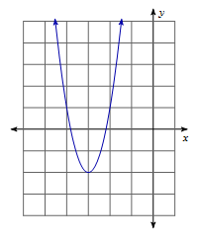
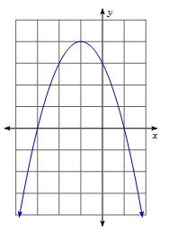
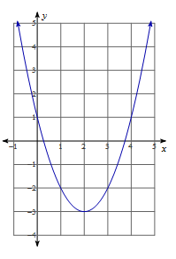
5. 6. 7.

8. Write the equation of a quadratic function that translates down 7 and left 8.
9. Write the equation of a quadratic function that translates up 11, right 9, and stretches by 4.
10. What transformation will occur with $f\left(x\right)={(-x)}^{2}$?

Thursday-

Friday-

