Algebra 2 Honors- Week 14 Homework

Monday-
Transformations of Polynomial Functions Assignment
For 1 and 2, given that a cube with side $x$ has the volume$f\left(x\right)=x^{3}$, draw a picture of the cube represented by the given function and then graph the volume on a coordinate plane. Be sure to note the appropriate domain and range for each graph.
1. $f\left(x\right)={3\left(x+2\right)}^{3}$ 2.$f\left(x\right)={\frac{1}{4}x}^{3}+4$
3. Can I use the model $f\left(x\right)={-x}^{3}$ to represent a cube? Why or why not?
Sketch the graph of the function by starting with the graph of a parent function and applying transformations. Be sure to include the three anchor points.
4. $f\left(x\right)={(x-2)}^{4}$ 5. $f\left(x\right)={(x+3)}^{3}-4$ 6.$f\left(x\right)={-(x+4)}^{5}$ 7. $f\left(x\right)={-3x}^{2}+4$ 8. $f\left(x\right)={2\left(x+1\right)}^{3}+2$
For 9 and 10, describe the transformations from one polynomial to the next.
9. $f\left(x\right)=\left(x-2\right)(x+4)^{2}(x-3)$ to $g\left(x\right)=-1/2\left(x-2\right)(x+4)^{2}(x-3)$
10. $f\left(x\right)=\left(x+5\right)\left(x+2\right)(x-1)$ to $g\left(x\right)=\left(x+7\right)\left(x+2\right)(x-1)$

Tuesday-
Modeling Volume with Polynomials Assignment
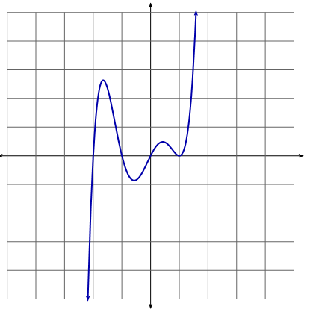
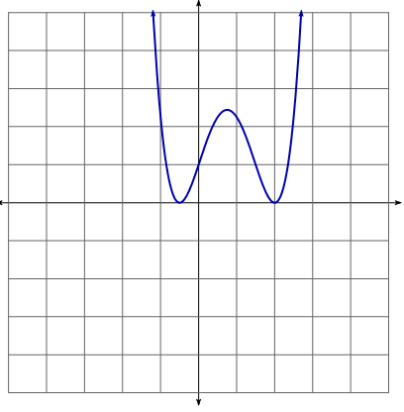
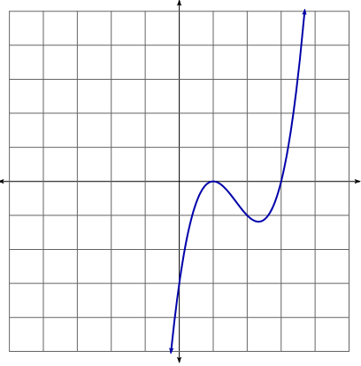
Estimate any local minimums or maximums and the intervals of increasing and decreasing (use Interval Notation).
1. 2. 3.

4. Determine which polynomials have an even degree and which have an odd degree.
5. Which polynomials have zeros that repeat or have a multiplicity of 2?
6. Do you think any of these polynomials have any imaginary roots? Why or why not?
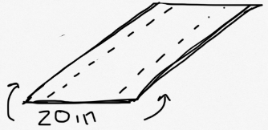
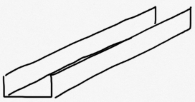
A rectangular piece of metal is 20 inches wide. It is to be made into a rain gutter by turning up the edges to form parallel sides.

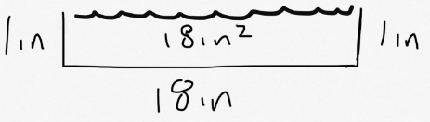
We want the rain gutter to hold as much as possible. For example, if we folded up one inch on each side, we would get a cross section area of 1in x 18in which is 18 in².

7. If the vertical side of the gutter has length x, write a polynomial function to model the area of the cross section.

8. What is the highest vertical side (in whole inches) that this rain gutter can have? What area would this cross section have? Do you think this is the biggest possible area?

9.How much should be folded up on each side to get the biggest cross section area? (Hint- you can make a chart and/or draws some diagrams.) Put this on the back of the paper.

10. What are the domain and range of the problem? What do they mean in terms of the rain gutter?

Wednesday- Catch up on homework from last week and study for test tomorrow!

Practice Test for Polynomial Functions Unit
Learning Objectives:
- Divide polynomials using long division.
- Divide polynomials using synthetic division.
- Use synthetic division to determine evaluate a function.
- Determine whether a binomial is a factor a polynomial.
- Use the roots of a polynomial to write a polynomial function.
- Solve a polynomial equation with rational roots.
- Solve a polynomial equation with rational and irrational roots.
- Graph a polynomial using the zeros and end behavior.
- Identify the end behavior of a polynomial function.
- Graph a polynomial using transformations.
- Identify the local minimum and maximums of a polynomial function.
- Identify the interval of increase and decrease of a polynomial function.
- Model volume with a polynomial function.

Question # | Learning Objective | Know It | Feel Unsure |  | Right | Wrong | Simple Mistake | Need to Study
1 | A
2 | B
3 | C
4 | D
5 | E
6 | F
7 | G
8 | H
9 | I, L
10 | J, L
11 | K, L
12 | I, J
13 | M
14 | N
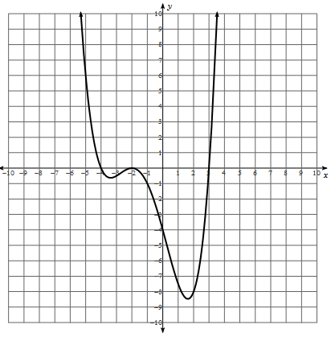
1.Divide $x^{2}+3x-1$ into $x^{3}+5x^{2}+4x-1$using polynomial long division.
2. Use synthetic division to divide $2x-1$ into $x^{3}-3x^{2}+7x-4$.
3. Given ${f\left(x\right)=x}^{4}-2x^{3}+7x-4$, find f(3).
4. Determine whether $x+3$is a root of ${f\left(x\right)=2x}^{3}+4x^{2}-5x+9$.
5. Write a polynomial equation given the roots: 2, 3, 5i.
6. Find all the rational roots for: $x^{3}-x^{2}-14x+24=0$.
7. Find all the rational and irrational roots for: $2x^{4}-5x^{3}+8x^{2}-15x+6=0$.
8. Given ${f\left(x\right)= x}^{3}+3x^{2}-9x+5=0$, find the zeros and sketch a graph.
9. Describe the end behavior of the given polynomial: ${-5x}^{4}-x^{2}+25=0$.
10. Use transformations to graph: $f\left(x\right)=2(x-3)^{3}+4$.
11. Identify the local minimums and/or maximums as well as the intervals of increasing and decreasing.
12. A box with a square base has a height that is two inches more than the length or width.
a)Write a polynomial function that models the volume of this box.
b) What is the volume of the box if the base has side length 5in?
c) What is the length of the base if the polynomial has 45 in³?

Thursday- Test Day! (No Homework)

Friday-

