Algebra 2 Honors- Week 3 Homework

Monday-
Daniel is playing his favorite video game and noticed that the points he earned every minute follow a linear pattern. Here is a table showing his total points for the first several minutes of play.
Minutes: x | Points: f(x)
0 | 1550
1 | 1900
2 | 2250
3 | 2600
4 | 2950

- Write a function that represents this scenario.

- After 10 minutes, how many points will he have?

- If Daniel has 12,050 points, how many minutes has he been playing?

Tuesday-
Each of these scenarios represent a linear situation. Find the equation of each in slope-intercept form. For each problem, identify what the slope and the y-intercept mean to the scenario.

- The length of a person’s femur and height are linearly related. One person has a 40 cm femur and is 162 cm tall. Another person has a 45 cm femur and is 173 cm tall.

- Steven sells vacuums on commission. He made $235 selling 5 vacuums and $376 selling 8 vacuums.

- The Smiths had to have a plumber come out twice this year. The first time he was there for 3 hours and charged them $196. The second time he was there for 5 hours and charged them $280.

- Using a certain calling card, a 5-minute overseas call costs $5.91 and a 10-minute call costs $10.86.

Wednesday-
Amazon is selling some of its DVDs for $3. Leah has $30 that she can spend. Here is a function that models this situation: f(x) = 30 – 3x

Thursday-
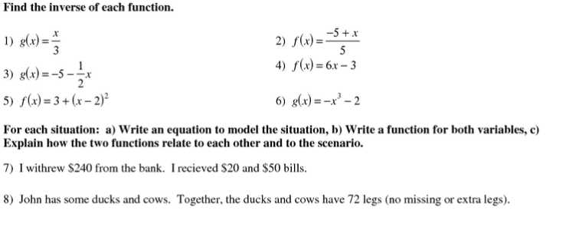

Friday-
