Algebra 2 Honors- Week 7 Homework

**Monday-**

**Laws of Exponents Assignment**

These problems have some of the most common mistakes that students make with exponents. Three of these problems are correct. If they are incorrect, explain the mistake and give the correct solution.

1. 2. 3.

4. 5. 6.

7. 8. 9.

10. 11. 12.

13. 14.

15. 16.

17. 18.



**Tuesday-** (Whatever you didn’t finish in class)

**Wednesday-**

**Operations with Polynomial Functions Assignment**

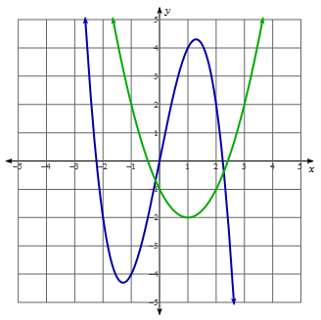Sketch the graph of the sum of these two functions. For 2 and 3, find the $f\left(x\right)+g(x)$ and $f\left(x\right)-g(x)$.

**1.**  **2. $f\left(x\right)= 2x^{2}+5x-3$** and $g\left(x\right)= 5x^{2}+7x-3$**3. $f\left(x\right)= 5x^{3}-7x^{2}-2x-1$** and $g\left(x\right)=-3x^{2}+8x-2$

**4.** Find two cubic functions whose sum is a quadratic.

**5.** Find two quadratic functions whose sum is $S\left(x\right)=x+5$.

**6.** To print a novel, it costs $500 plus $4 per book. Each book

sells for $16.

**a)** C(x) represents the cost per day of x books. Find C(x).

**b)** R(x) represents the total money earned from selling books. Find R(x).

**c)** P(x) represent the profit which takes the revenue R(x) and subtracts the cost C(x). Find P(x).

d) Find the profit if 1200 books are sold.

**Thursday-**

**Operations with Polynomial Functions Assignment**

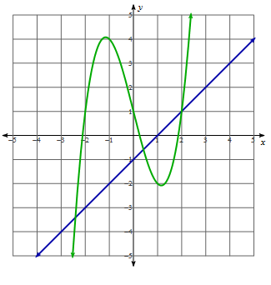**Sketch the product of these two functions. For 2 - 4, find the $f\left(x\right)∙g(x)$.**

**1.**  **2. $f\left(x\right)=5x-3$** and $g\left(x\right)= 7x-3$**3. $f\left(x\right)=x^{2}-2x-1$** and $g\left(x\right)=8x-2$

**4. $f\left(x\right)=x^{2}+5x-3$**  and $g\left(x\right)=3x^{2}+2x+1$

**5.** Find two polynomials whose product will be fifth degree.

**6.** Nikki recently painted a picture where the width is five

inches longer than the length. She put a 3 inch wide mat around the picture.

1. Draw a diagram of the painting and its mat.
2. Write a function, P(x), for the area of the painting.
3. Write functions, L(x) and W(x), for the length and width of the mat.
4. Write a function, A(x), for the total area of both the mat and the painting.
5. Write a function, M(x), for the area of the mat.

**Friday-**

