Practice Test for Polynomial Functions Unit
Learning Objectives:
- Divide polynomials using long division.
- Divide polynomials using synthetic division.
- Use synthetic division to determine evaluate a function.
- Determine whether a binomial is a factor a polynomial.
- Use the roots of a polynomial to write a polynomial function.
- Solve a polynomial equation with rational roots.
- Solve a polynomial equation with rational and irrational roots.
- Graph a polynomial using the zeros and end behavior.
- Identify the end behavior of a polynomial function.
- Graph a polynomial using transformations.
- Identify the local minimum and maximums of a polynomial function.
- Identify the interval of increase and decrease of a polynomial function.
- Model volume with a polynomial function.

Question # | Learning Objective | Know It | Feel Unsure |  | Right | Wrong | Simple Mistake | Need to Study
1 | A
2 | B
3 | C
4 | D
5 | E
6 | F
7 | G
8 | H
9 | I, L
10 | J, L
11 | K, L
12 | I, J
13 | M
14 | N
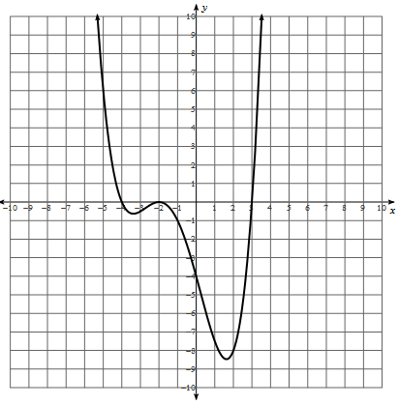
1.Divide $x^{2}+3x-1$ into $x^{3}+5x^{2}+4x-1$using polynomial long division.
2. Use synthetic division to divide $2x-1$ into $x^{3}-3x^{2}+7x-4$.
3. Given ${f\left(x\right)=x}^{4}-2x^{3}+7x-4$, find f(3).
4. Determine whether $x+3$is a root of ${f\left(x\right)=2x}^{3}+4x^{2}-5x+9$.
5. Write a polynomial equation given the roots: 2, 3, 5i.
6. Find all the rational roots for: $x^{3}-x^{2}-14x+24=0$.
7. Find all the rational and irrational roots for: $2x^{4}-5x^{3}+8x^{2}-15x+6=0$.
8. Given ${f\left(x\right)= x}^{3}+3x^{2}-9x+5=0$, find the zeros and sketch a graph.
9. Describe the end behavior of the given polynomial: ${-5x}^{4}-x^{2}+25=0$.
10. Use transformations to graph: $f\left(x\right)=2(x-3)^{3}+4$.
11. Identify the local minimums and/or maximums as well as the intervals of increasing and decreasing.
12. Write a polynomial equation for the graph to the right (notice the x and y-intercepts).
13. A box with a square base has a height that is two inches more than the length or width.
a)Write a polynomial function that models the volume of this box.
b) What is the volume of the box if the base has side length 5in?
c) What is the length of the base if the polynomial has 45 in³?

